**Design Thinking Process for**

**DOST STARBOOKS: Whiz Challenge**

Project Documentation Submitted to the Faculty of the

School of Computing and Information Technologies

Asia Pacific College

In Partial Fulfillment of the Requirements for

Systems Analysis and Detailed Design

MSYADD1

Submitted by:

**Dumbrique, Kelly (Team Leader)**

**Gercan, Arcielle Marie (Member)**

**Quianzon, Shandrae Lois (Member)**

**Salipande, Janice Maxene (Member)**

G06 NEXUS – SF 231

Submitted to:

**Mr. Jose Eugenio L. Quesada**

Course Instructor

August 2025

1st Term

A.Y. 2025

# **ABOUT THE CLIENT**

The Department of Science and Technology (DOST) is the lead government agency in the Philippines tasked with directing, coordinating, and implementing policies, programs, and projects related to science and technology [1]. Its mandate covers a broad range of sectors, from education and industry to health and disaster resilience, all with the goal of using innovation to support national development and improve the quality of life of Filipinos [1].

Under DOST is the Science and Technology Information Institute (DOST-STII), which serves as the agency’s official information arm. DOST-STII plays a key role in collecting, managing, and disseminating credible Science, Technology, and Innovation (STI) information across the country [2].

In line with this, DOST-STII’s mission focuses on [2]:

* Providing credible and inclusive STI information through resource sharing and efficient delivery systems;
* Promoting public awareness, understanding, and appreciation of STI and its role in national development; and
* Empowering key stakeholders as partners and advocates in building a culture of STI.

To fulfill this mission, DOST-STII developed STARBOOKS, short for Science and Technology Academic and Research-Based Openly Operated KioskS [3]. STARBOOKS is the country’s first offline digital library designed to bring S&T learning resources to communities that lack reliable internet access. Installed in schools, libraries, and public centers nationwide, it provides free and ready access to a wide array of educational materials, including science references, research papers, instructional and livelihood videos, K–12 learning modules, and financial literacy resources [4]. These materials are sourced from the DOST-STII Library and its institutional partners [3]-[4].

# **ABOUT THE PROJECT**

To further promote scientific literacy and student engagement, the STARBOOKS Whiz Challenge was introduced as a gamified educational platform that complements the STARBOOKS project [3]-[4]. Developed by DOST-STII, this application aims to make learning about Science, Technology, Engineering, and Mathematics (STEM) topics more enjoyable, especially for students attending DOST events, science fairs, and public exhibits.

The STARBOOKS Whiz Challenge is a standalone, offline quiz-based application that runs on STARBOOKS kiosk setups [3]-[4]. It primarily features a solo quiz game where players answer multiple-choice questions on various STEM topics, aligned with the Grade 1 to 12 curriculum. It allows players to choose a difficulty level: Easy, Average, or Difficult, and answer a fixed set of questions accordingly.

A unique feature of the Whiz Challenge is its badge and reward system. After completing a quiz:

* Players who answer all questions correctly earn a badge for the chosen difficulty level.
* Once a player collects three badges in the same difficulty, they become eligible to claim a physical reward, such as educational tokens or small prizes at the DOST booth.

This simple reward-based gamification approach motivates students to try multiple times, review their knowledge, and improve their performance, all while having fun. It transforms the traditional quiz experience into something more interactive, competitive, and goal-driven.

The STARBOOKS Whiz Challenge is currently deployed during DOST-led public events, science exhibits, education fairs, and outreach activities, where STARBOOKS kiosks are physically set up. Because it works offline, the system remains accessible and functional even in venues with no internet connectivity, ensuring equal participation from students in both urban and rural areas [3]-[4].

Through this initiative, DOST-STII continues to reinforce the value of accessible, innovative learning tools, empowering the next generation of Filipino learners to explore science and technology with curiosity, confidence, and excitement [5].

# **STAGE 1: EMPATHIZE**

The Empathize stage focuses on understanding the needs, motivations, pain points, and experiences of the stakeholders involved with the STARBOOKS: Whiz Challenge application. The goal of this stage is to immerse the team in the users’ perspectives and the context in which the product is used, allowing us to identify both explicit requirements and latent needs.

For this project, the team sought to understand the perspectives of three main stakeholder groups:

1. **The STARBOOKS project team** – responsible for the vision, development, and maintenance of the application.
2. **Potential administrators** – such as teachers or librarians from STARBOOKS-partnered schools who may manage the application or assist players.
3. **End-users (players)** – primarily students from elementary to senior high school who interact with the application during events, fairs or in partner institutions.

Due to project constraints and limited access to partner schools, direct interviews with administrators and student players were not possible during this stage. Instead, insights were gathered from:

* **Ms. Marievic V. Narquita** – STARBOOKS Unit Head
* **Mr. McGyver C. Basaya** – STARBOOKS Lead Programmer, with access to both the player and admin perspectives

These interviews provided a baseline understanding of the application’s current goals, user demographics, and functional scope.

## **1.1. Interview with the Clients**

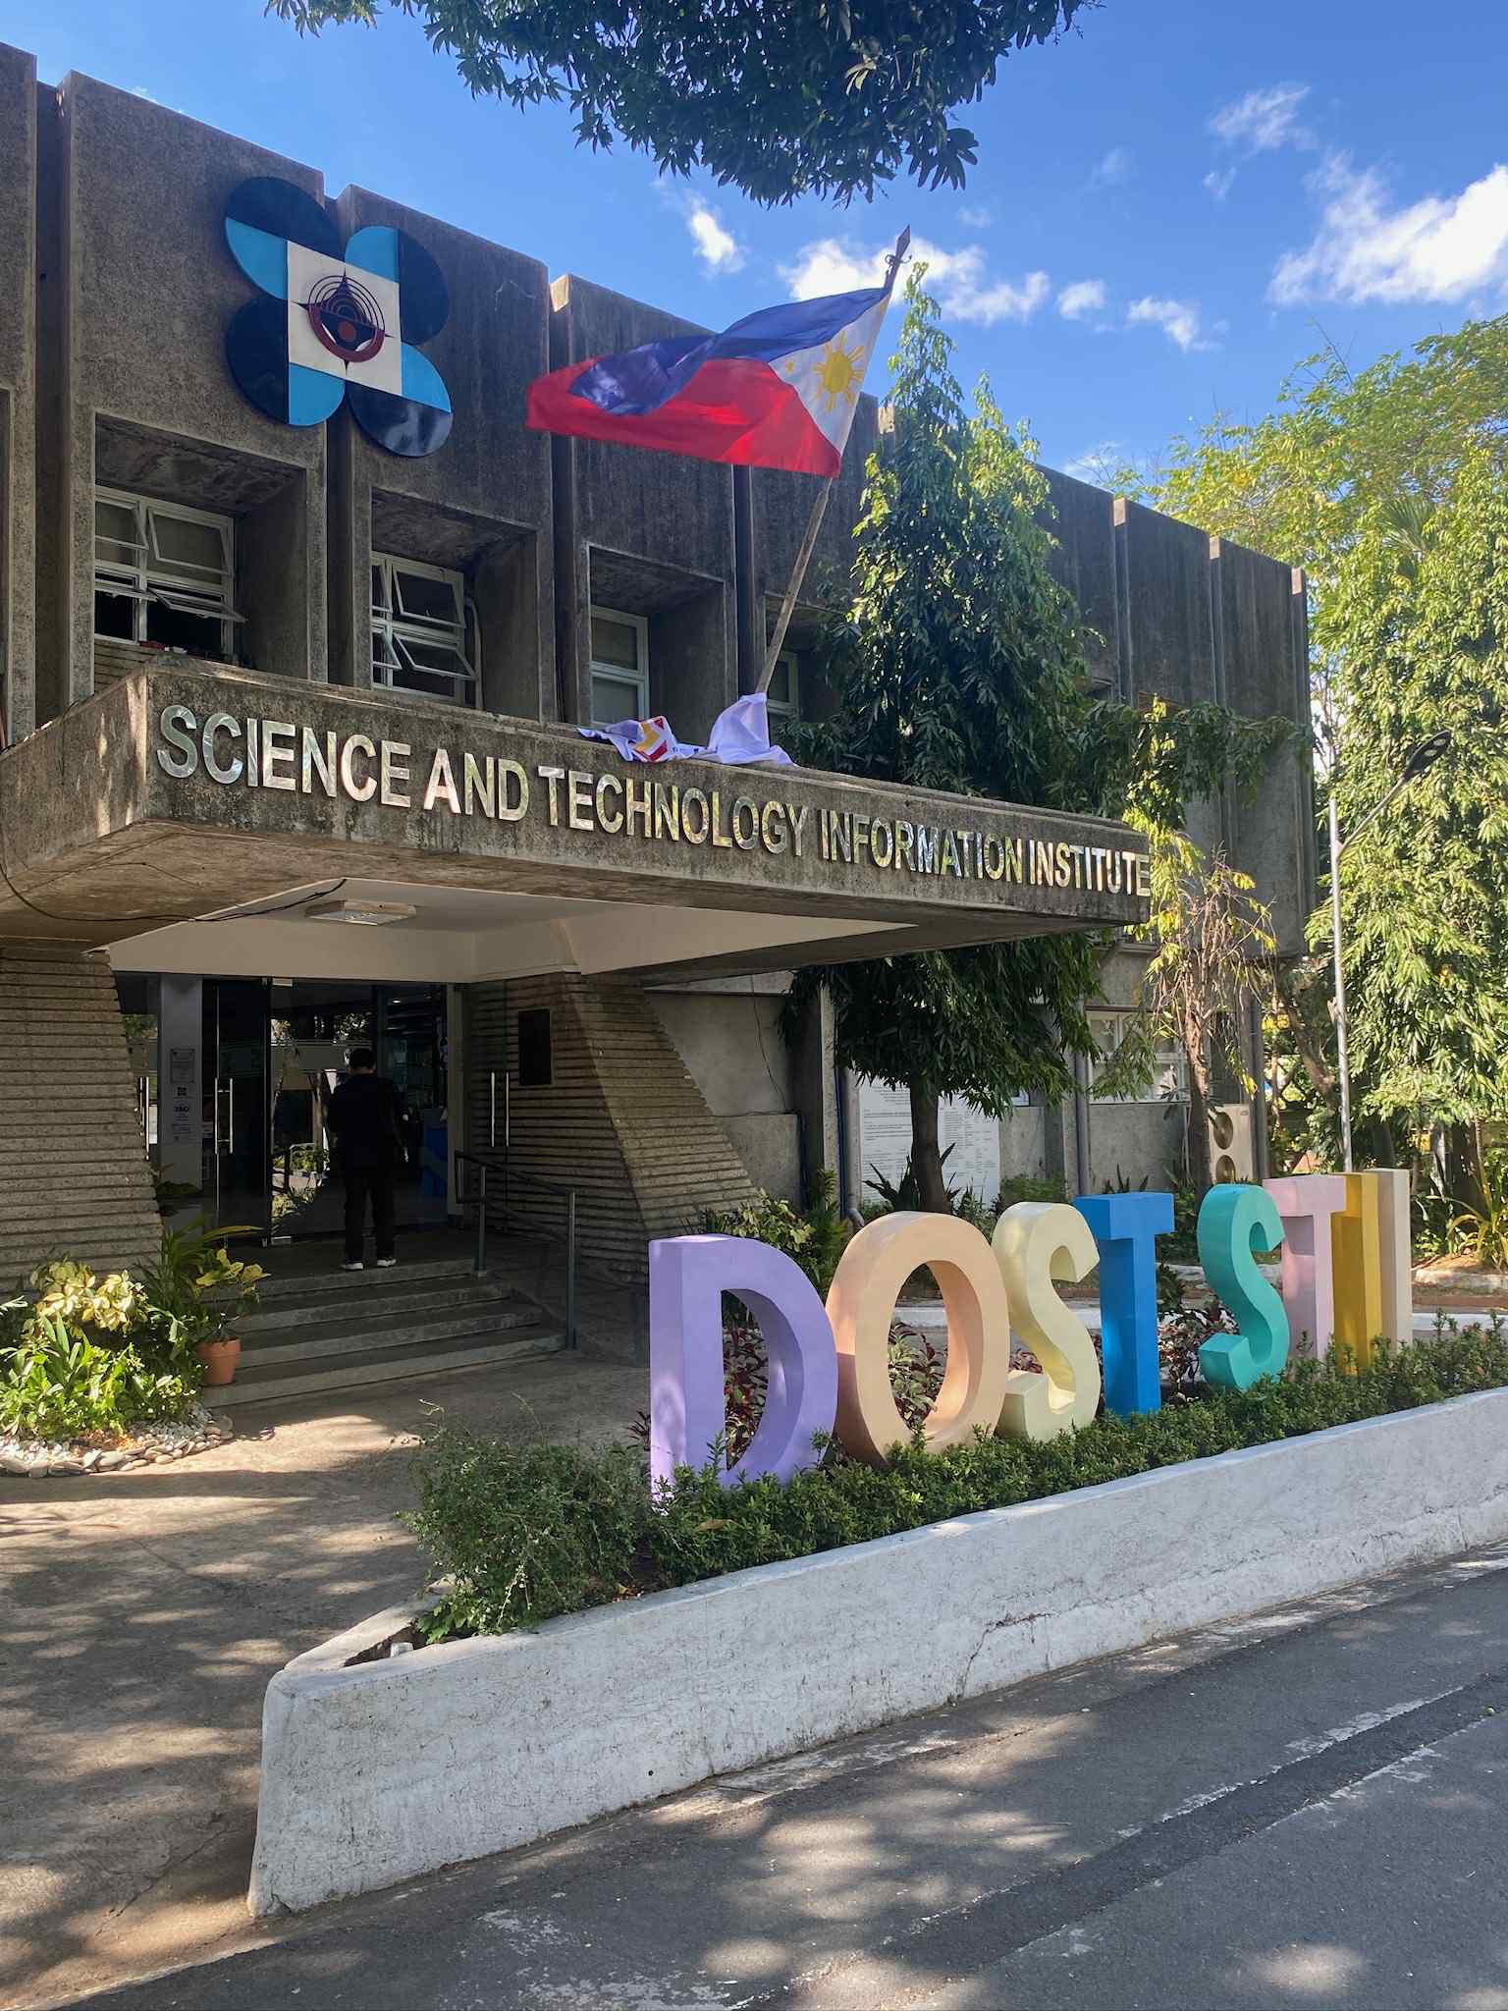

Figure 1 DOST-STII Building

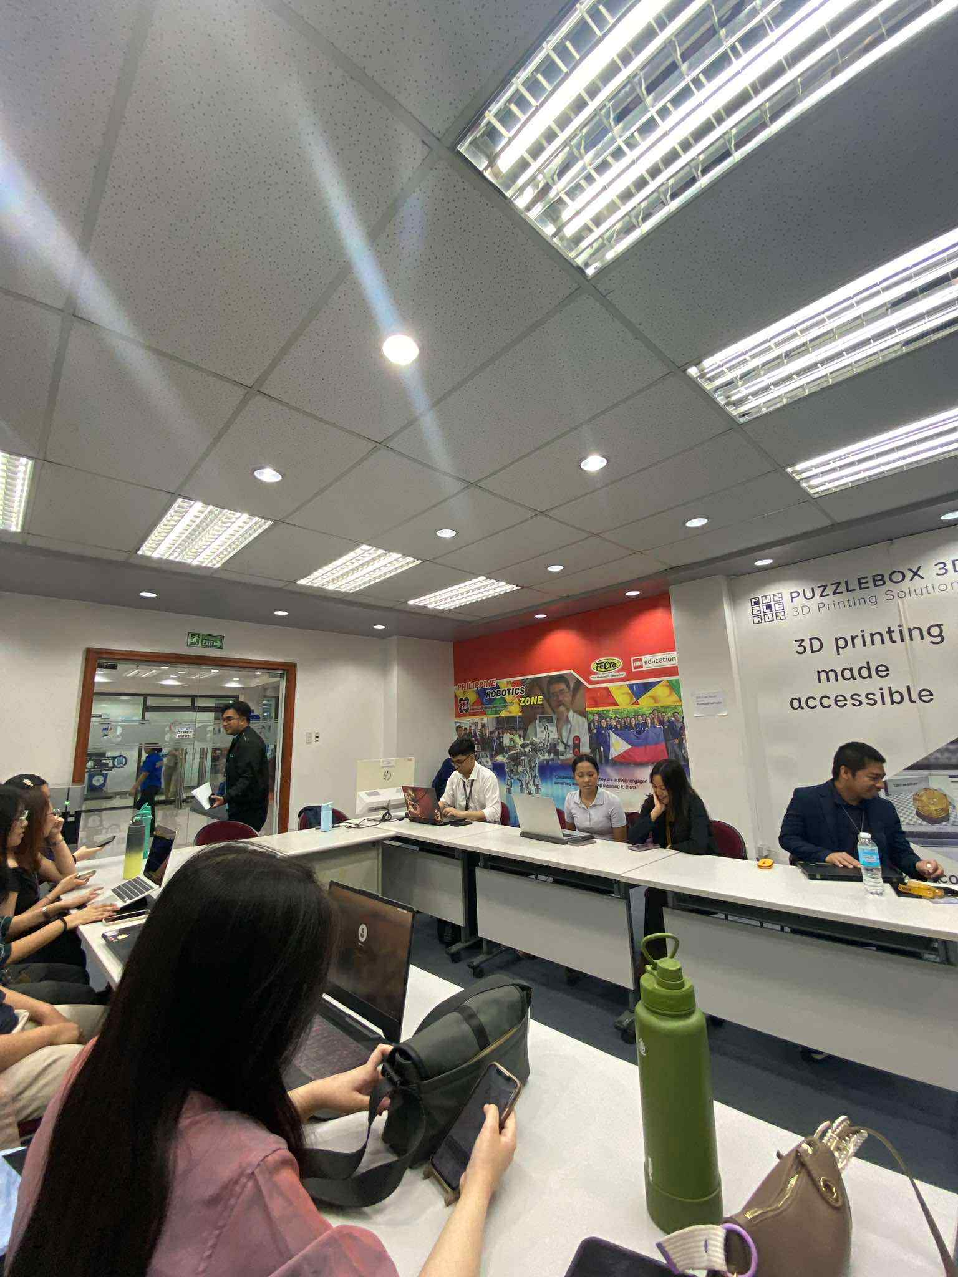

Figure 2 Interview with STARBOOKS Team

On April 30, 2025, the team went to the DOST–Science and Technology Information Institute (STII) building in Taguig City for our first face-to-face meeting with the STARBOOKS team. This was our chance to ask open-ended questions and really dig deeper into the “why” and “how” of the Whiz Challenge app. The team came prepared with a list of questions focused on its purpose, audience, and limitations, as well as ideas for improvements.

For this section, Table 1 below shows the summarized questions and answers from our interview with Ms. Marievic V. Narquita, the unit head of STARBOOKS.

Table 1 Interview with Ms. Marievic V. Narquita (STARBOOKS Unit Head)

|  |  |  |
| --- | --- | --- |
| **#** | **Question** | **Answer** |
| 1 | Why did DOST-STII create the STARBOOKS: Whiz Challenge app? | The app was made mainly to entertain students and visitors during DOST events and science fairs. It’s also a way to get them interested in Science and Math through a fun quiz game. |
| 2 | In what contexts or events is the app usually played? | It’s mostly played during exhibits, science fairs, and DOST outreach programs. It’s also available in some schools and libraries that have STARBOOKS kiosks. |
| 3 | Who are the main players of the app? | Mostly students from elementary, high school, and senior high school. They usually get to play it during events or when they visit places with a STARBOOKS kiosk. |
| 4 | How do players usually access the app? | The app is available offline in kiosks prepared by the organizers at events or installed in schools. |
| 5 | What are the app’s main strengths or appealing features for players? | Students like the competitive quiz style and the scoring system. It’s also easy to use, so players can start right away without needing a lot of instructions. |
| 6 | What challenges or limitations have you observed in the current app? | Right now, it only has a solo quiz mode with badges. There aren’t other game modes to keep players engaged for long. It also can’t track scores or player progress over time. |
| 7 | What kind of feedback have you received from students or teachers about the app? | There’s no formal way to gather feedback yet, but during events, students seem to enjoy playing. Some have casually mentioned they’d like more variety in the games. |
| 8 | What improvements or new features would you like to see in future versions? | More game modes, especially player battles, a better-looking interface, a reward system that makes students want to keep playing, and features for tracking performance and scores. |
| 9 | How does the STARBOOKS team measure the success of the Whiz Challenge app? | Mostly by observing how many students play and/or claim rewards during events and how engaged they look. |
| 10 | How does the Whiz Challenge app align with STARBOOKS’ mission? | STARBOOKS wants to make science and technology resources more accessible, especially in areas with fewer opportunities. The app supports this by making learning more interactive and enjoyable for students. |

During the same meeting, the team also got the chance to talk to Mr. McGyver C. Basaya, lead programmer for the Whiz Challenge app. Since he has direct experience working on the code and has access to the admin panel, his answers gave us both a technical view and an idea of how the app is managed from an admin’s perspective.

The questions for him covered the current features, technical setup, limitations, and what it’s like for possible admin users such as teachers or librarians. Table 2 below summarizes his responses.

Table 2 Interview with Mr. McGyver C. Basaya (STARBOOKS Lead Programmer)

|  |  |  |
| --- | --- | --- |
| **#** | **Question** | **Answer** |
| 1 | What is your role in the development of the Whiz Challenge app? | I worked on programming the game, integrating the quiz logic, and setting up the admin panel features. |
| 2 | Can you describe the main features available in the current version? | The current app has a solo quiz mode with Science and Math categories. It awards badges based on performance. The admin panel allows adding and editing quiz questions. |
| 3 | How is the app usually set up during events? | It’s installed on desktop PCs and can run offline to avoid internet issues. |
| 4 | Does the app collect any player data or statistics? | Yes, the admin can see the whole list of players and their badges on each kiosk. |
| 5 | How are quiz questions managed in the current system? | They’re stored in a local database that’s part of the app’s offline package. Admins can add or edit questions through the admin panel. |
| 6 | What technical limitations have you observed with the current app? | Since it’s offline, any updates to the questions need to be done manually on each kiosk. Also, the players can only access their profiles on the same kiosks they logged into because syncing is not possible. |
| 7 | Are there any security or stability issues that need to be addressed? | Since it’s a local setup, the quiz content can be edited directly if someone has access to the admin panel. |
| 8 | What improvements would you like to see from a development perspective? | Adding different game modes, improve interface, track performance, view analytics, and a way to sync data across different kiosks. |
| 9 | How long does it usually take to update or prepare the app for an event? | If it’s just changing questions, it can be done in a few minutes. But if there are new features or bug fixes, it depends on the complexity. |
| 10 | What do you think admins like teachers or librarians would find challenging in using the current system? | Since there’s no analytics or tracking, admins can’t see the overall performance of users. Also, the interface is simple but not very modern, so it might not be as engaging for them to use regularly. |

## **1.2. Personas**

Personas are fictional yet realistic representations of key users, built from real data, interviews, and observations. They help the design team visualize who they are designing for, not just in terms of demographics, but also behaviors, goals, frustrations, and motivations. By putting a “face” and “story” to the users, personas make it easier to keep their needs at the center of every design decision.

For the STARBOOKS: Whiz Challenge project, the team developed two types of personas:

* **Actual Personas** – These were based on real interviews we conducted with members of the STARBOOKS team. For this stage, we created profiles for Ms. Marievic V. Narquita, the STARBOOKS Unit Head, and Mr. McGyver C. Basaya, the Lead Programmer. Both play important roles in the app’s creation and maintenance, giving us valuable insights into the purpose of the application, its current challenges, and their vision for its improvement.
* **Theoretical Personas** – These were created to represent the types of users we couldn’t directly interview due to access limitations. These include possible admins such as teachers or librarians, and players who typically interact with the app during DOST exhibit fairs. The goal of these personas is to anticipate their needs, frustrations, and expectations based on secondhand information from our interviewees, combined with our own user research and assumptions.

By working with both actual and theoretical personas, we ensured that our design process addresses both the confirmed needs of stakeholders we spoke to and the likely needs of those we couldn’t directly reach but will ultimately use or interact with the application.

**Persona 1: Ms. Marievic V. Narquita (Actual)**

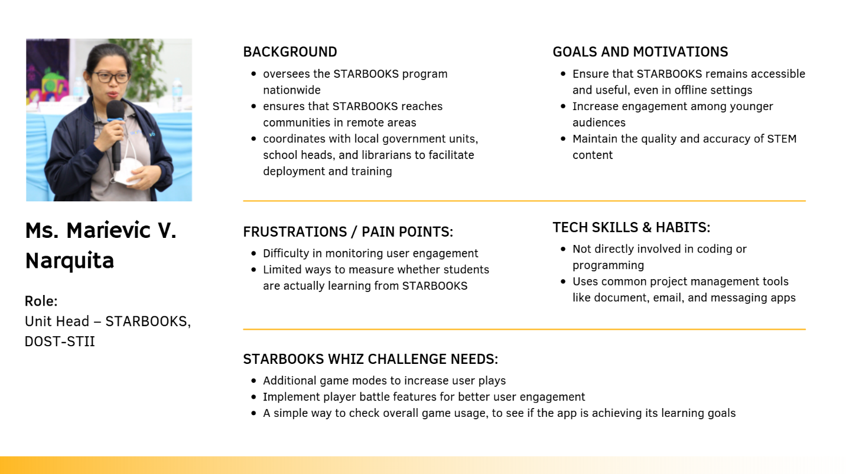

Figure 3 Persona 1

**Persona 2: Mr. McGyver C. Basaya (Actual)**

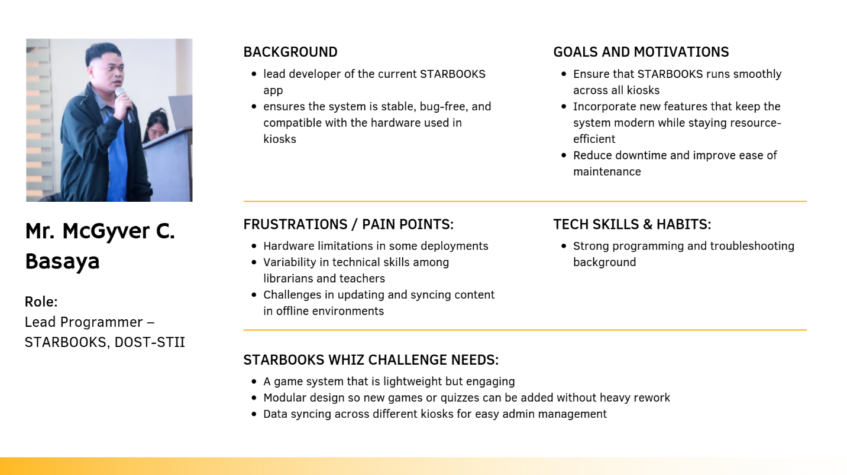

Figure 4 Persona 2

**Persona 3: Chloe Ramirez (Theoretical)**

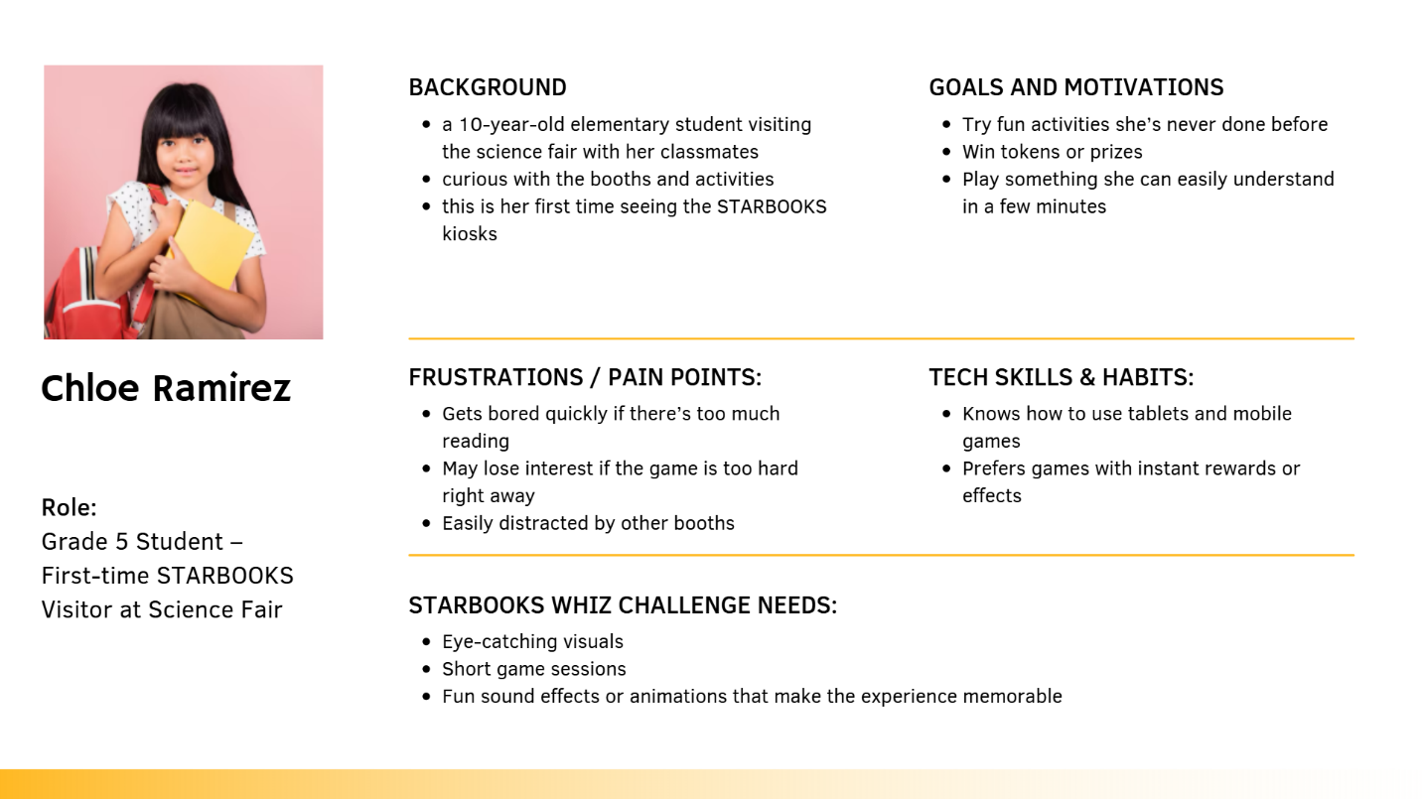

Figure 5 Persona 3

**Persona 4: John Ray Santos (Theoretical)**

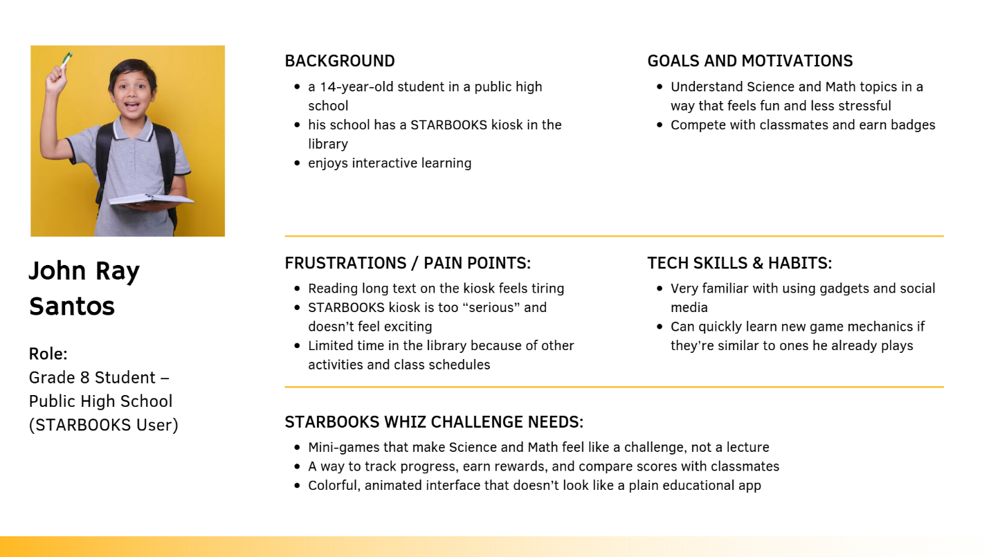

Figure 6 Persona 4

**Persona 5: Mr. Carlo Mendoza (Theoretical)**

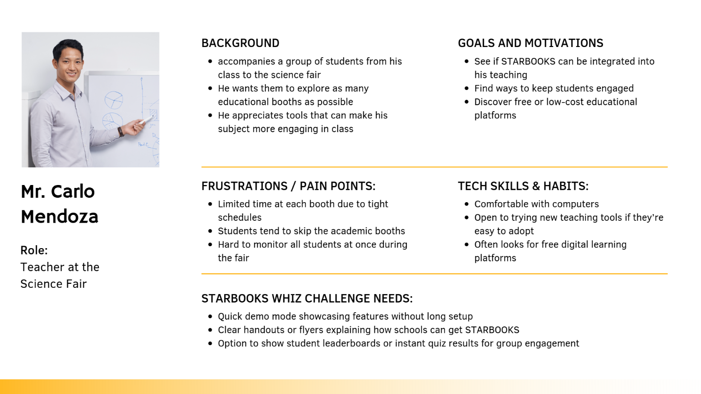

Figure 7 Persona 5

**Persona 6: Ms. Liza de Vera (Theoretical)**

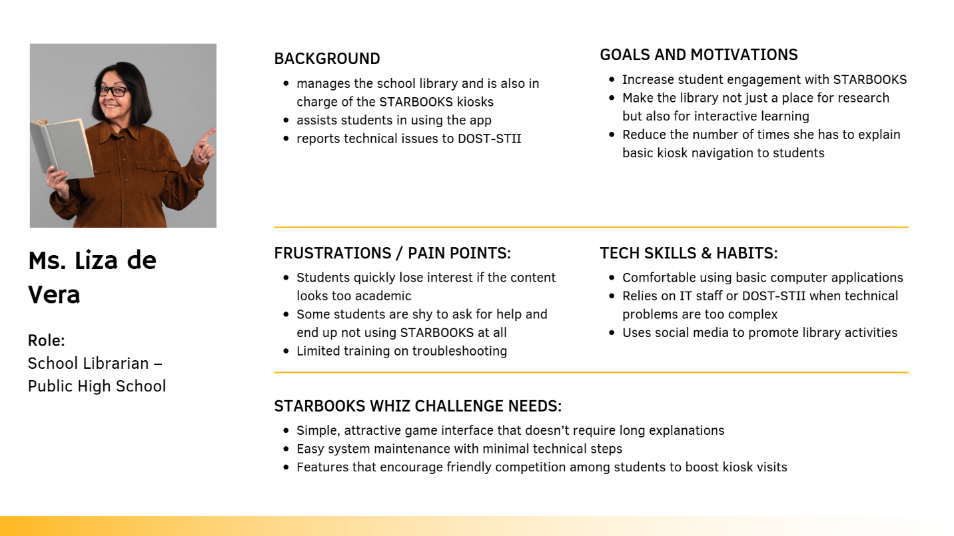

Figure 8 Persona 6

## **1.3. Empathy Maps**

Empathy maps are visual tools that help the team step into the shoes of each persona and see the system from their perspective. An empathy map captures what a persona might say, think, do, and feel in a given context, along with their goals and pain points.

By exploring these dimensions, we can identify not only the functional needs of our users, but also their motivations, frustrations, and expectations. This helps guide design decisions that are user-centered and grounded in real scenarios.

**Empathy Map 1: Ms. Marievic V. Narquita (STARBOOKS Unit Head)**

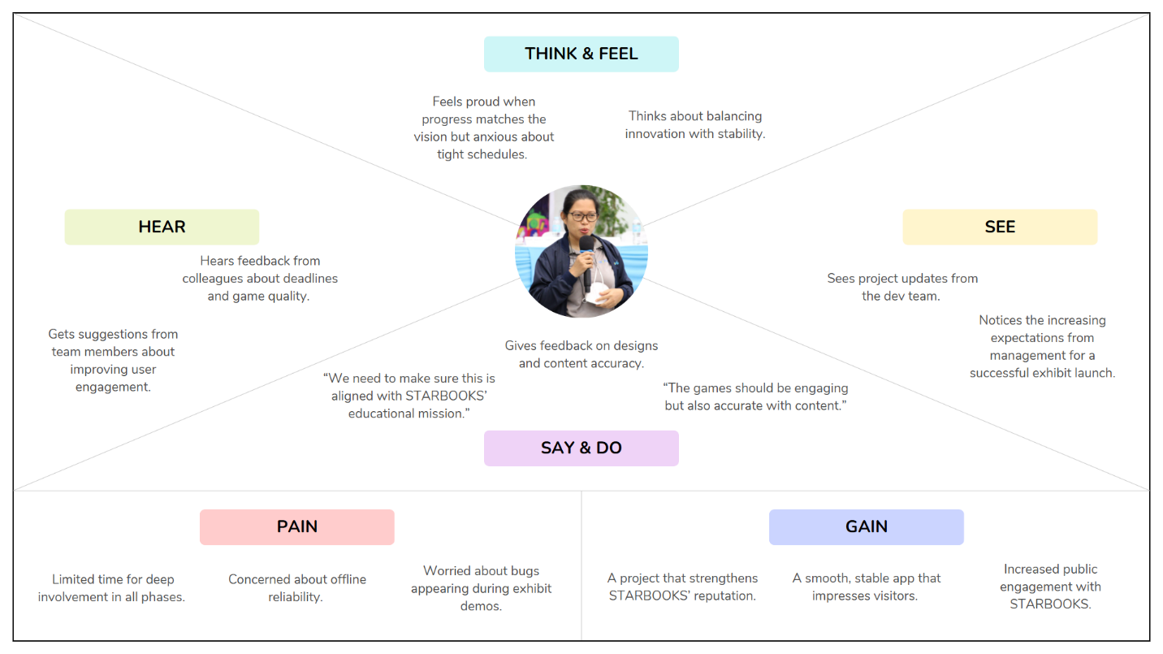

Figure 9 Empathy Map 1

**Empathy Map 2: Mr. McGyver C. Basaya (STARBOOKS Lead Programmer)**

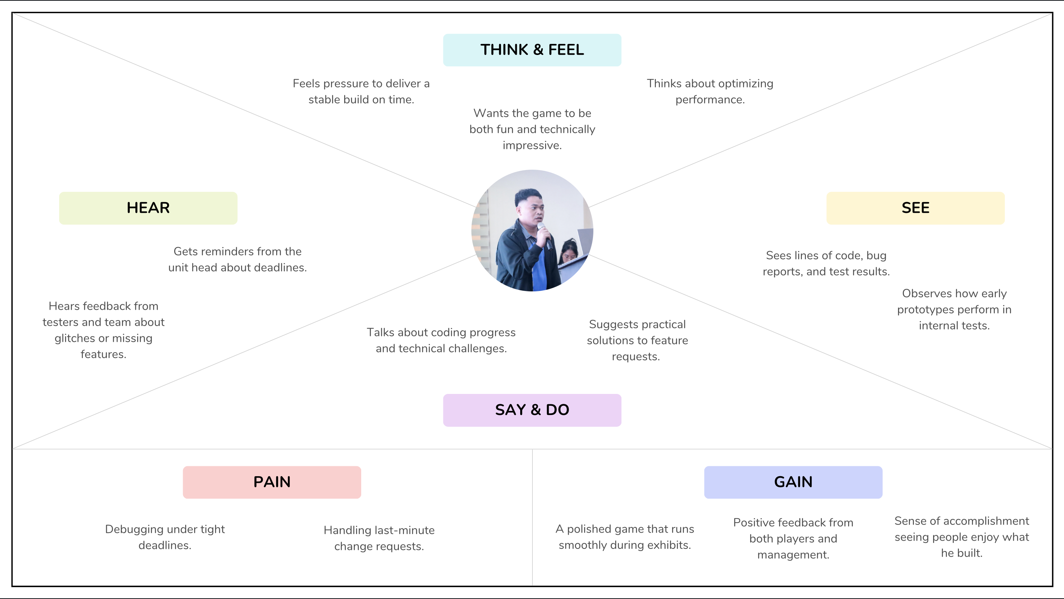

Figure 10 Empathy Map 2

**Empathy Map 3: Chloe Ramirez (First-time Exhibit Visitor)**

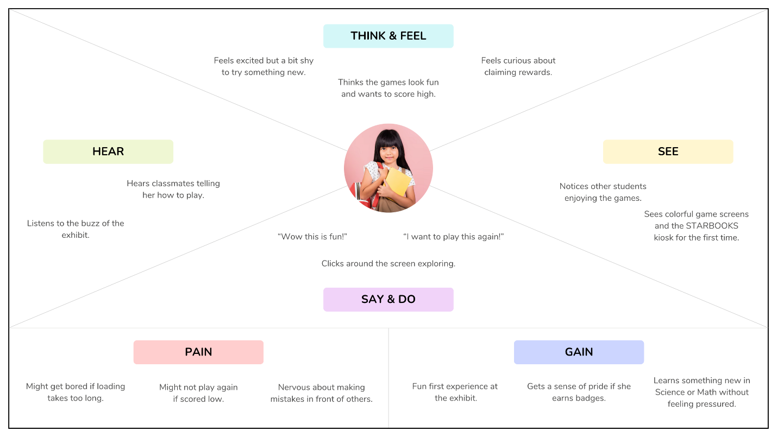

Figure 11 Empathy Map 3

**Empathy Map 4: John Ray Santos (STARBOOKS User)**

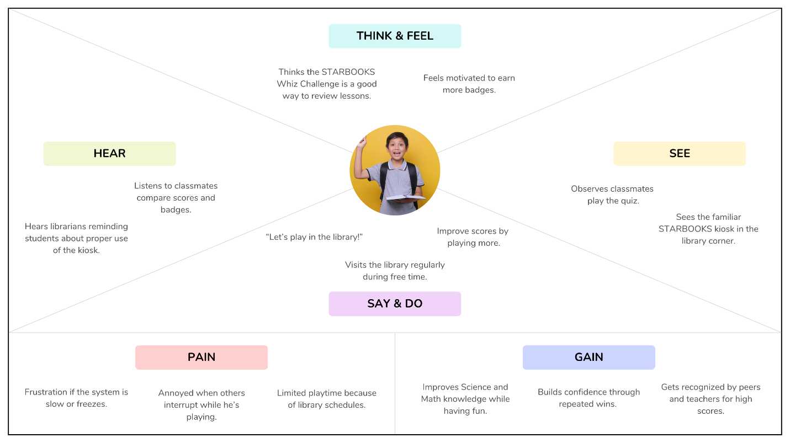

Figure 12 Empathy Map 4

**Empathy Map 5: Mr. Carlo Mendoza (Teacher at the Science Fair)**

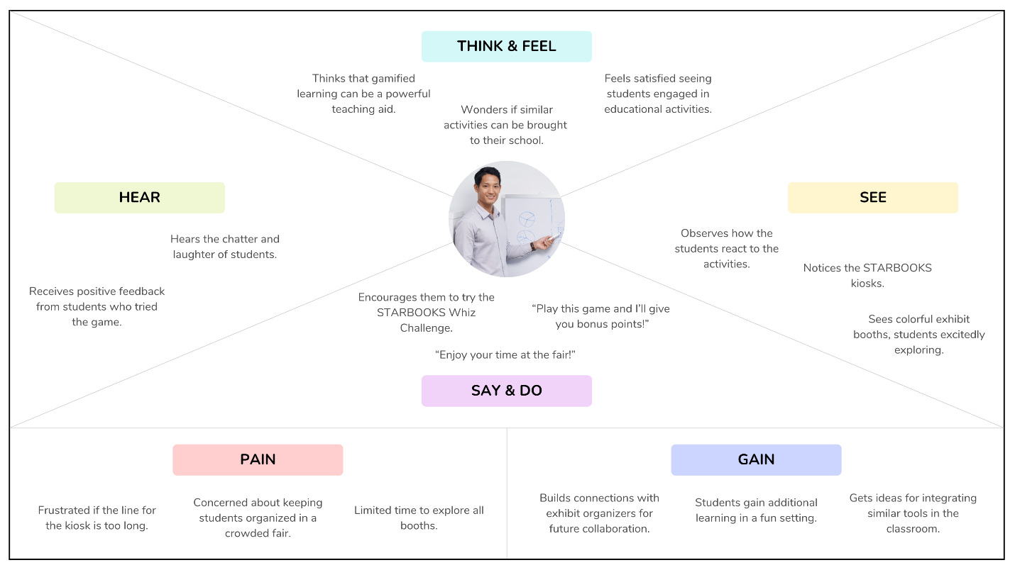

Figure 13 Empathy Map 5

**Empathy Map 6: Ms. Liza de Vera (School Librarian)**

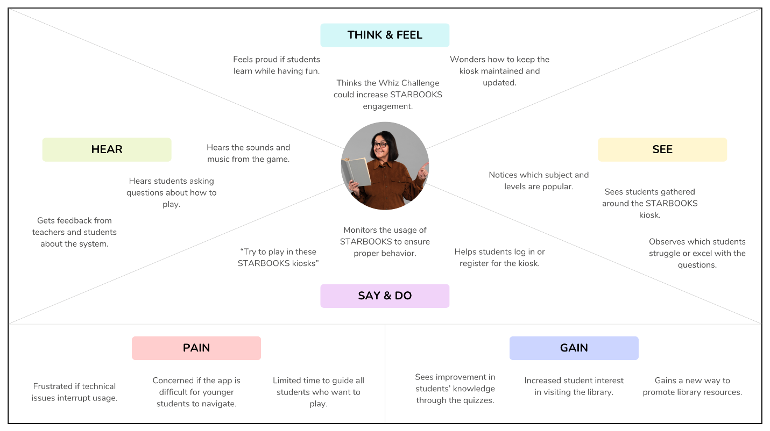

Figure 14 Empathy Map 6

## **1.4. Pain-Gain Analysis**

Pain–Gain Analysis is a simple, yet effective tool used to identify the challenges (pains) that users face and the benefits (gains) they expect or experience when interacting with a system. By mapping out these factors for each persona, the team can better understand user needs, frustrations, and motivations. This helps in prioritizing features, improving user experience, and ensuring that the final product delivers maximum value while minimizing obstacles. Table 3 shows the summarized pain-gain analysis with the six personas.

Table 3 Pain-Gain Analysis

|  |  |  |
| --- | --- | --- |
| **Persona** | **Pains** | **Gains** |
| Ms. Marievic V. Narquita  (STARBOOKS Unit Head) | Balancing educational goals with engaging gameplay; Time constraints for managing project; Limited budget/resources | Delivering an educational tool that works offline; Showcasing innovation during exhibits; Enhancing STARBOOKS appeal |
| Mr. McGyver C. Basaya (Lead Programmer) | Risk of technical issues during exhibits; Time pressure for development; Ensuring smooth performance offline | Creating a polished, bug-free system; Positive feedback from players |
| Chloe Ramirez  (First-time Exhibit Visitor) | Difficulty understanding controls at first; May feel intimidated by questions | Fun, memorable exhibit experience; Learning without realizing it; Earning badges |
| John Ray Santos (STARBOOKS User) | Limited time to play during breaks; Difficulty answering harder questions | Enjoyable learning during free time; Comparing scores and badges with friends; Improving Science and Math skills |
| Mr. Carlo Mendoza (Teacher) | Keeping students engaged in large groups; Limited time for each student to try the system | A ready-made learning tool; Students excited about Science & Math; Easy integration into class visits |
| Ms. Liza de Vera  (School Librarian) | Technical issues disrupt usage; Younger students struggle with navigation; Limited ability to guide all players | Higher student interest in library visits; Students improve knowledge while having fun; New way to promote library resources |

**Insights:**

Looking at all the pain–gain results from the six personas, we noticed a few patterns that kept coming up:

**1. Common Pains Across Personas**

* **Getting started and figuring things out** – First-time users often have a hard time figuring out how to play right away without someone guiding them.
* **Limited time** – Teachers and students usually only have limited time to try the games, whether it’s during a class trip to the fair or quick breaks in the library.
* **Possible tech issues** – Both the project lead and lead programmer are concerned about how the system will handle heavy use during exhibit days.

**2. Common Gains Across Personas**

* **Fun while learning** – Everyone appreciates that the games mix enjoyment with Science and Math lessons, making the subjects feel less intimidating.
* **Rewards and competition as motivation** – Badges and prizes keep students and visitors coming back for more tries.
* **Good image for schools and exhibits** – Teachers, librarians, and project leads see the system as something that can help promote their school or exhibit as modern and engaging.

**3. Implications for System Design**

* Make the onboarding process very simple so that even first-time or younger users can try without much help.
* Design games to be short and easy to replay, so visitors can enjoy them even with limited time.
* Focus on strong offline performance and have quick ways to fix issues during busy exhibit days.

# **REFERENCES**

[1] Department of Science and Technology, “Mandate, Mission, and Vision,” Dost.gov.ph, Apr. 26, 2014. <https://www.dost.gov.ph/transparency/about-dost/mandate-mission-and-vision.html>

[2] Super User, “Mission and Vision,” Dost.gov.ph, 2022. <https://www.stii.dost.gov.ph/transparency/about-us/mission-and-vision>

[3] Department of Science and Technology – Science and Technology Information Institute (DOST-STII), "STARBOOKS: A Decade of Bringing Library-in-a-Box to Communities," Department of Science and Technology, Taguig City, 2021.

[4] Department of Science and Technology – Science and Technology Information Institute (DOST-STII), "About STARBOOKS," Department of Science and Technology – Science and Technology Information Institute, Taguig City.

[5] Department of Science and Technology – Science and Technology Information Institute, "DOST's STARBOOKS reinvents itself with more upgrades on its 10th year," Department of Science and Technology – Science and Technology Information Institute, Taguig City, 2021.